Freight companies make process-relevant data available and usable in real-time
Contact
Annabelle Kliesing
PR and Marketing Manager
Tel +49 811 9595-201
Fax +49 811 9595-199
Email presse@eurolog.com
EURO-LOG AG
Am Söldnermoos 17
D-85399 Hallbergmoos-Munich
Germany
www.eurolog.com

The Realtime Process Network, supported by the Bavarian state government, works to help medium-sized freight companies link their processes in real-time

Hallbergmoos-Munich, 23 November 2012 – EURO-LOG has partnered with a number of medium-sized freight companies and the Fraunhofer Society to form the “Realtime Process Network”, with the aim of linking logistics processes along the supply chain in real-time. 24plus Systemverkehre, Logwin Solutions, Spedition Lode and Wolf Spedition are representing the logistics sector as participants in the project. From the scientific community, the Fraunhofer working group for Supply Chain Services (SCS) and the Fraunhofer Institute for Applied and Integrated Security (AISEC) are leading the development of the “Realtime Process Network”. The aim of the research project is to develop and test an innovative and collaborative cloud-based real-time process network for freight providers in the individually packaged cargo market. For freight companies, it is important that process-relevant data is usable as soon as possible after its collection. The project is being financed as part of the Bavarian “Information and communication technology” support programme.
Currently, the majority of data is transferred in batches upon completion of a process step. However, this approach does not allow companies to plan capacity and resources in advance. The collaborative network aims to use real-time data intelligently to enable companies to operate in a more cost-effective way. In the Realtime Process Network, real-time information is defined as information that is available before the final process result is achieved, or before the completion of a full process step. This information can be used to plan more effectively based on actual utilisation data, rather than estimates calculated from historical data.
The freight companies participating in the project should see long-term benefits – the real-time IT structures that will be built during the research project are a major competitive advantage for medium-sized freight carriers. These structures will be implemented using future-proof cloud technologies. The cloud enables data from existing local IT systems operated by various partners to be rendered usable quickly and securely, in a flexible and standardised integration process. Cross-company links are also established via cloud services, so that all information is available to the partners authorised to access it at all times. Manual processes, such as advising customers of collection volumes by phone, become superfluous, saving time and enabling the freight company to compile more effective advance plans. Thanks to the real-time transfer of relevant process data, for example, the company is able to plan its resources more accurately, with complete clarity as to which volumes need to be collected from which customers and when. Optimised resource planning is also better for the environment, as it enables freight companies to plan their routes more efficiently and minimise CO₂ emissions.
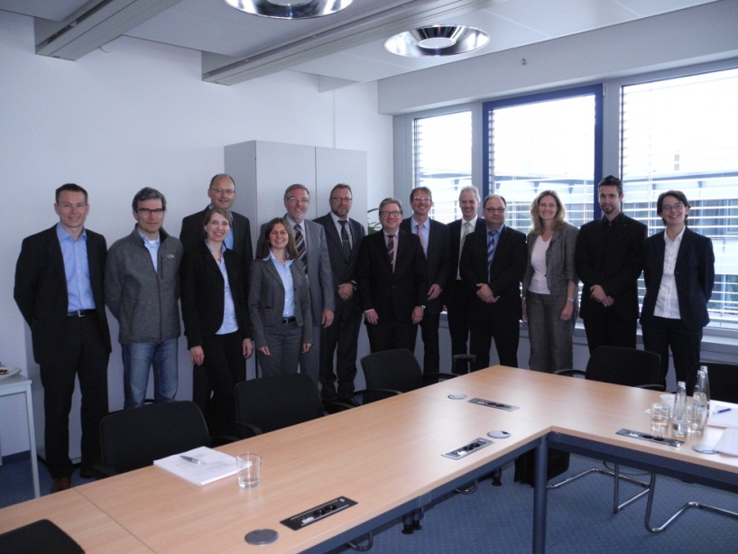
EURO-LOG AG already has many years of experience in networking information from even the most diverse organisations. By implementing industry solutions, EURO-LOG has acquired a sound knowledge of business processes across a wide range of industries, particularly in the automotive and freight sectors. All of these projects require the necessary information to be brought together in one central location. The findings from the “RFID-based Automotive Networks” (RAN) project, sponsored by the Federal Ministry for Economic Affairs and Energy, can be applied to the example of individually packaged cargo used in the “Realtime Process Network” project.
Collaborators in the “Realtime Process Network” project (left to right): Roland Fischer (Fraunhofer IIS, SCS working group), Rüdiger Lode (Spedition Lode), Sabine Ellerhold (EURO-LOG), Heinz Wolf jun. (Wolf Spedition), Iryna Tsvihun (Fraunhofer AISEC), Horst Neumann (EURO-LOG), Raimund Juriga (Logwin Solutions), Werner Schelter (Logwin Solutions), Jörg Fürbacher (EURO-LOG), Dr. Jürgen Becher (EURO-LOG), Reiner Joseph (24plus Systemverkehre), Angelika Schneider (Fraunhofer AISEC), Matthias Aumüller (Fraunhofer AISEC), Katrin Greiser (EURO-LOG)

EURO-LOG AG
For 25 years, EURO-LOG has been providing IT services to shippers and logistics service providers who know that logistics is much more than just transporting goods from A to B. With the help of the EUROLOG SCM PLATFORM, the IT service provider connects all process partners involved in real time, creates a transparent supply chain to improve cooperation and offers managers maximum control.
The innovative IT solutions, which provide open service interfaces, are ready to use on the EUROLOG SCM PLATFORM: B2B Integration, Procurement Management, Transport Management, ONE TRACK Shipment Tracking, Container Management and Mobile Logistics Solutions. EURO-LOG’s solutions are currently used by international customers operating in sectors such as automotive, ecommerce & retail, industry and logistics as well as many others.
EURO-LOG was founded in 1992 as a joint venture by Deutsche Telekom, France Telecom and Digital Equipment. The firm became a “people-owned company” in 1997 and developed into one of the leading providers of IT and process integration. Today, at the head office in Hallbergmoos-Munich with its own computer centres, more than 80 employees provide for transparency in logistic processes with innovative software applications and individual links.

Website: www.eurolog.com
Youtube: www.youtube.com/channel/eurolog
Facebook: www.facebook.com/eurolog
Twitter: twitter.com/euro_log_ag
LinkedIn: www.linkedin.com/company/euro-log-ag

